ToonTalk Evaluation Report (6)
Date : February 7, 2000
To : Ken Kahn
From: T. Matsuzawa / JEI

- Environment
PC IBM PC/AT Compatible
OS Windows 98
Application ToonTalk Beta 010200

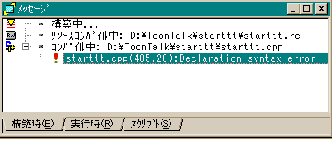
- Details of Problem
  - Starttt.cpp
Unfortunately, I cannot compile this file owing to "Declaration syntax error".
I found that the prototype of following function was different from older version.
Please advise me what I should do.

t_time seconds_since_1970()

long seconds_since_1970() // This is older vesion

The latest starttt.exe is working well. But no Japanese messages are shown in the option screen
except title of dialog boxes.
I’m sorry – t_time should have been time_t.
I’ll look into why there are no Japanese messages soon.

  - Play game
I didn't have enough time to evaluate. But it seems your modifications works very well.
Thanks. I will continue to evaluate.

  - Free play
- IDS_PICK_UP_HLP3
I made the following changes in the "japan.rc"
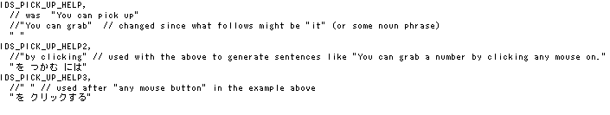
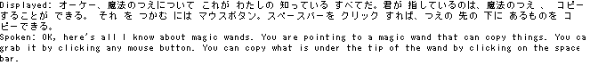
But it seems that the IDS_PICK_UP_HELP3 is not shown.

Thanks for pointing this out. IDS_PICK_UP_HELP3 was being used in only 4 out of the 6 places it should. Fixed now.

- IDS_VACUUM_RESTORE_HELP4
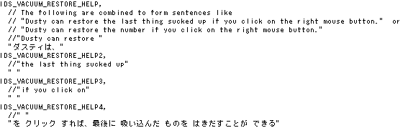
I need the above entry. Because it is ignored with the latest version.

X
Fixed now, thanks.

- Extra messages
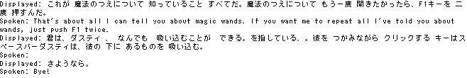After Marty finishes his explanation, if I point other tools by moving mouse, then unexpected messages are shown. These messages are not logged as spoken messages.

No messages are logged.
I wasn’t able to reproduce this. See attached feb9b.txt (with talk balloons) and feb9c.txt (with subtitles) and let me know if you see any problems.

- New requests
I also need the following entries. So please kindly add them on your strings.h
IDS_INTS_MADE_NEGATIVE_HELP5 - done
IDS_INTS_MULTIPLICATION_HELP3_2 –done
I believe the following two are taken care by using IDS_PICK_UP_HELP2 and IDS_PICK_UP_HELP3. If the text for IDS_DROP_HELP_2 is not identical to IDS_PICK_UP_HELP2 and IDS_DROP_HELP_3 isn’t identical to IDS_PICK_UP_HELP3 then let me know and I’ll add them
IDS_DROP_HELP_2
IDS_DROP_HELP_3
IDS_BOMB_USED_HOUSE_HELP5 -done
IDS_BOMB_USED_TB_HELP_2 -done
IDS_BOMB_USED_TB_HELP2_2 -done

- Misc.
- The latest resource files
I'm attaching the latest resource files rc.zip that include the following files.
japan.rc – I noticed that the last 4 or 5 entries in this file were still in English
new.rc – also from IDS_TROUBLE_SHOOT_EXTENSION_NOT_INSTALLED to IDS_GOES_WITH not translated
puzzle.rc
Thanks.

- New DLL files
The other day, you sent me some new DLL files. Please let me explain them at your convenience.
Do you mean usnt32.dll? That is the latest English string table. Depending upon how you configured your system, it replaces either a file of the same name or ustt32.dll.

